-

**A**

**MINI PROJECT REPORT**

**ON**

**“E-COMMERCE ONLINE SHOPPING WEBSITE”**

A mini project work submitted to Khaja Bandanawaz University, Kalaburagi,

In partial fulfilment of the requirements for the award of the degree of,

**BACHELOR OF ENGINEERING IN COMPUTER SCIENCE & ENGINEERING**

Submitted by:

Afrah Ruheen

21KB02BS[005]

Asma Jabeen

21KB02BS[012]

Bi Bi ASIYA

21KB02BS[019]

**UNDER THE GUIDANCE OF**

**Prof. ASRA FATIMA**

**M.TEC**

**DEPARTMENT OF COMPUTER SCIENCE & ENGINEERING,**

**FACULTY OF ENGINEERING & TECHNOLOGY,**

**KHAJA BANDANAWAZ UNIVERSITY**

**Kalaburagi-585104**

**2024-2025**



**FACULTY OF ENGINEERING AND TECHNOLOGY**

**DEPARTMENT OF COMPUTER SCIENCE AND ENGINEERING**

**CERTIFICATE**

This is to certify that the WEB mini project on **“E-COMMERCE ONLINE SHOPPING WEBSITE”** is carried out by **AFHRA RUHEEN, ASMA JABEEN, BIBI ASIYA** ,are bonafied students of **Faculty of Engineering and Technology** in partial fulfilment of award of Degree of **Bachelor of Engineering in Computer Science and Engineering** of the Khaja Bandanawaz University, Kalaburagi during the academic year **2024-25**. It is certified that all corrections, suggestions indicated for internal assessment have been incorporated in the report deposited in the department library.

The mini project report has been approved as it satisfies the academic requirements in respect of mini project work prescribed for the said degree.

**UNDER THE GUIDANCE OF HEAD OF THE DEPARTMENT**

**Prof.ASRA FATIMA Dr.Sameena Banu**

**ACKNOWLEDGEMENT**

The opportunity we had to make a mini-project was a great chance for learning and professional development. Therefore, we consider ourself as a very lucky individuals as we were provided with an opportunity to be a part of it. We are also grateful for having a chance to meet so many wonderful people and professionals who led us through this project.

We express our deepest thanks to “Prof. ASRA FATIMA”, for taking part in useful decision and giving necessary advices. We choose this moment to acknowledge her contribution gracefully.

We are very much thankful and obliged to our Head of Department Dr. SAMEENA BANU for her encouragement and insightful comments throughout my internship.

We express our deep sense of gratitude to our Dean Dr. S K AZAM who has provided us an opportunity to fulfill the most cherished desire to reach our goal

|  |
| --- |
| **Place:** Kalaburagi **AFRAH RUHEEN** |
| **Date: ASMA JABEEN**  **BIBI ASIYA** |
|  |

**Table Of Contents**

1 INTRODUCTION 1

1.1 Overview 1

1.2 Purpose 2

1.3 Scope 3

1.4 Objective 4

Chapter 02 6

METHODOLOGY 6

3 SYSTEM REQUIREMENTS 12

3.1 Hardware Requirements: 12

3.2 Software Requirements: 12

RESULTS: 13

**ABSTRACT**

Online classifieds are used to provide the customers with huge amount of information. This is a site to login to get the latest updates of the automobiles, matrimony and real estates. An easy way to buy a product just sitting in front of your computers by registering into our site.

This is to facilitate all people who are busy with their works and have no time to get their desired goods. We are here to provide you all the best and suitable places for sale. If once you register into our site, then you are benefitted with our latest updates of the sales!

This is used to advertise the products with images. One can easily login to get any kind of information. Here the user is also facilitated to directly interact with the consumer. He can get the desired product with different rates and quality.

The main goal is to provide the customer with various goods just by sitting in front of a computer He can get the goods easily without moving from place to place.

Consumers can also have a chance of introducing their products not only in a single place but throughout the world using online classifieds. This system allows the user to interact directly just by sitting in front of the computer. Consumers have a chance of comparing the product and purchase the desired one

This document fully and formally describes the requirements of the proposed said project system. It sets out the functional and non-functional requirements and includes a description of the user interface and documentation and training requirements.

# 1 INTRODUCTION

E-commerce is fast gaining ground as an accepted and used business paradigm. More and more business houses are implementing web sites providing functionality for performing commercial transactions over the web. It is reasonable to say that the process of shopping on the web is becoming commonplace. The objective of this project is to develop a general purpose e-commerce store where product like clothes can be bought from the comfort of home through the Internet. However, for implementation purposes, this paper will deal with an online shopping for clothes. An online store is a virtual store on the Internet where customers can browse the catalog and select products of interest. The selected items may be collected in a shopping cart. At checkout time, the items in the shopping cart will be presented as an order. At that time, more information will be needed to complete the transaction. Usually, the customer will be asked to fill or select a billing address, a shipping address, a shipping option, and payment information such as credit card number. An e-mail notification is sent to the customer as soon as the order is placed.

## Overview

The e-commerce industry has experienced tremendous growth over the past few years, fueled by advancements in technology and changing consumer preferences. This project aims to create a fully functional e-commerce online shopping website, designed to provide a seamless and user-friendly shopping experience for customers. The platform will allow users to browse a wide range of products, add them to a shopping cart, make secure purchases, and track their orders.

The website will serve two primary user groups: customers and administrators. Customers will have access to key functionalities such as user registration, product search, detailed product pages, shopping cart management, and a secure checkout process. On the other hand, administrators will manage product listings, customer data, and orders through a secure backend system, allowing them to update product information, track sales, and maintain inventory.

The frontend development of an e-commerce website involves creating the visual and interactive elements that users directly engage with. This project focuses on using HTML, CSS, and JavaScript to build a functional and attractive online shopping platform. The key aspects of the frontend development process include layout design, visual styling, interactivity, and performance optimization.

This overview outlines the primary goals and components of the project, focusing on delivering a high-performance, scalable, and secure e-commerce platform that meets the needs of both customers and business owners. Through this project, we aim to demonstrate the potential of e-commerce solutions in modern retail, emphasizing the importance of user experience, security, and system reliability.

## Purpose

The purpose of this project is to develop the frontend of an e-commerce online shopping website utilizing HTML, CSS, and JavaScript. The frontend serves as the interface through which users interact with the website, and its effectiveness is crucial in shaping the overall user experience. The primary goals of this project are:

1. **To Create an Engaging User Interface:**
   * **Goal:** Design a visually appealing and user-friendly interface that attracts and retains users.
   * **Approach:** Utilize HTML for structuring content, CSS for styling and layout, and JavaScript for dynamic elements to enhance the visual appeal and usability of the website.
2. **To Ensure Responsive Design:**
   * **Goal:** Provide a seamless and consistent user experience across various devices, including desktops, tablets, and smartphones.
   * **Approach:** Implement responsive design techniques using CSS media queries and flexible grid layouts to ensure that the website adapts to different screen sizes and orientations.
3. **To Implement Interactive Features:**
   * **Goal:** Enhance user engagement by adding interactive elements that improve functionality and usability.
   * **Approach:** Use JavaScript to integrate features such as product sliders, dynamic content updates, interactive forms, and real-time shopping cart updates.
4. **To Facilitate Efficient Product Browsing and Searching:**
   * **Goal:** Enable users to easily find and explore products, improving their shopping experience and increasing the likelihood of purchases.
   * **Approach:** Develop user-friendly navigation menus, filtering options, and search functionalities using HTML, CSS, and JavaScript.
5. **To Streamline the Shopping Cart and Checkout Process:**
   * **Goal:** Provide a smooth and efficient process for users to manage their cart and complete transactions.
   * **Approach:** Implement JavaScript for real-time cart updates and form validation to ensure a seamless checkout experience.
6. **To Optimize Performance:**
   * **Goal:** Ensure that the website loads quickly and performs efficiently to enhance user satisfaction and retention.
   * **Approach:** Optimize images, minify CSS and JavaScript files, and use techniques such as lazy loading to improve page load times and overall performance.
7. **To Reflect Brand Identity:**
   * **Goal:** Ensure that the design and functionality of the website align with the brand’s identity and values.
   * **Approach:** Incorporate consistent branding elements such as colors, fonts, and logos to create a cohesive and professional appearance.

## Scope

The scope of this project encompasses the frontend development of an e-commerce online shopping website using HTML, CSS, and JavaScript. It focuses on designing and implementing the visual and interactive elements that users interact with directly. The scope includes the following key areas:

**1. Website Layout and Structure:**

* **HTML:** Create a clear and organized structure for the website, including the homepage, product pages, shopping cart, and checkout pages. Ensure that all content is semantically structured and accessible.

**2. Visual Design and Styling:**

* **CSS:** Develop and apply styles to enhance the visual appearance of the website. This includes designing layouts, choosing color schemes, setting typography, and ensuring consistent visual branding. Implement responsive design techniques to adapt the layout for different devices and screen sizes.

**3. Interactivity and Dynamic Features:**

* **JavaScript:** Implement interactive elements such as product sliders, dropdown menus, modals, and real-time updates to the shopping cart. Develop dynamic features that enhance user engagement and streamline interactions on the site.

**4. User Interface and Navigation:**

* **Design:** Create an intuitive and user-friendly interface that allows users to easily browse products, filter and sort items, manage their shopping cart, and complete purchases. Ensure that navigation menus and links are clear and functional.

**5. Performance Optimization:**

* **Techniques:** Optimize website performance to ensure fast load times and smooth operation. This includes compressing images, minifying CSS and JavaScript files, and implementing lazy loading for resources.

**6. Responsiveness:**

* **Design:** Ensure that the website provides a consistent user experience across a variety of devices, including desktops, tablets, and smartphones. Use responsive design principles and media queries to adapt the layout and functionality as needed.

**7. Form Handling and Validation:**

* **JavaScript:** Implement client-side form validation to ensure that user inputs are accurate and complete. Handle forms for registration, login, and checkout to enhance usability and prevent errors.

**8. Accessibility:**

* **Standards:** Ensure that the website meets accessibility standards to accommodate users with disabilities. This includes providing alternative text for images, ensuring proper contrast ratios, and enabling keyboard navigation.

**9. Security Considerations:**

* **Practices:** Implement basic client-side security measures to protect user data and interactions. Ensure that forms and inputs are validated to prevent common vulnerabilities.

**10. Testing and Quality Assurance:**

* **Processes:** Conduct thorough testing across different browsers and devices to ensure compatibility and performance. Address any issues related to functionality, design, and user experience.

**11. Documentation:**

* **Content:** Provide comprehensive documentation detailing the design, development process, and usage of the website. Include information on the technologies used, code structure, and instructions for future maintenance and updates.

## Objective

The objective of this project is to develop the frontend of an e-commerce website using HTML, CSS, and JavaScript. The specific goals are:

1. **Create a Visually Appealing Design:**
   * Develop a visually attractive and consistent design that aligns with modern web aesthetics and the brand's identity. Use HTML for structuring content and CSS for styling elements such as colors, fonts, and layouts.
2. **Ensure User-Friendly Navigation:**
   * Design intuitive navigation menus and interfaces that allow users to easily browse products, access different sections of the site, and manage their shopping cart. Focus on usability and ease of access.
3. **Implement Responsive Layouts:**
   * Develop a responsive design that provides a seamless experience across various devices and screen sizes. Use CSS media queries and flexible grid systems to ensure the website adapts to desktops, tablets, and smartphones.
4. **Enhance Interactivity:**
   * Integrate interactive elements such as product sliders, dropdown menus, and modals to engage users and enhance their browsing experience. Use JavaScript to add dynamic features and real-time updates.
5. **Optimize Performance:**
   * Improve website performance to ensure fast load times and smooth operation. Implement techniques like image optimization, CSS and JavaScript minification, and lazy loading to enhance speed and efficiency.
6. **Facilitate Effective Product Display:**
   * Create a clear and attractive presentation for products, including high-quality images, detailed descriptions, and pricing information. Ensure that product listings are easy to navigate and understand.
7. **Streamline Shopping Cart and Checkout:**
   * Develop a streamlined shopping cart and checkout process that minimizes friction and facilitates easy transactions. Implement features for managing cart items and a user-friendly checkout form with validation.
8. **Ensure Accessibility:**
   * Make the website accessible to users with disabilities by following accessibility best practices. Include features such as alternative text for images, proper color contrast, and keyboard navigation support.
9. **Implement Basic Security Measures:**
   * Incorporate basic client-side security practices to protect user data and interactions. Focus on secure form handling and input validation to prevent vulnerabilities.
10. **Provide Comprehensive Documentation:**
    * Create detailed documentation covering the design, development process, and usage of the website. Include instructions for future maintenance and updates to support ongoing development.

# 2 METHODOLOGY

**2.1 Overview of Frontend**

The front end is the part of the website users can see and interact with such as the graphical user interface (GUI) and the command line including the design, navigating menus, texts, images, videos, etc. The visual aspects of the website that can be seen and experienced by users are frontend.

**Frontend focuses on:**

• Markup and web languages such as HTML, CSS, JavaScript, and ancillary libraries commonly used in those languages such as Sass or jQuery

• Asynchronous request handling and AJAX

• Single-page applications (with frameworks like React, Angular or Vue.js)

• Web performance (largest content full paint, time to interactive,

• FPS animations and interactions, memory usage, etc.)

• Responsive web design • Cross-browser compatibility issues and workarounds

• End-to-end testing with a headless browser

• Search engine optimization

• Accessibility concerns

• Basic usage of image editing tools such as GIMP or Photoshop

• User Interface

**2.2 WEB-DEVELOPMENT**

Web development is a broad term for the work involved in developing a web site for the Internet (World Wide Web) or an intranet (a private network). Web development can range from developing the simplest static single page of plain text to the most complex web-based internet applications, electronic businesses, and social network services. A more comprehensive list of tasks to which web development commonly refers, may include web engineering, web design, web content development, client liaison, client-side/side scripting, web server and network security configuration, and e-commerce development. Among web professionals, "web development" usually refers to the main non-design aspects of building web sites: writing markup and coding. Most recently Web development has come to mean the creation of content management systems or CMS. These CMS can be made from scratch, proprietary or open source. In broad terms the CMS acts as middleware between the database and the user through the browser. A principle benefit of a CMS is that it allows non-technical people to make changes to their web site without having technical knowledge.

**2.3 WEB-SITE**

A website is a collection of related web pages, including multimedia content, typically identified with a common domain name, and published on at least one web server. A website may be accessible via a public Internet Protocol (IP) network, such as the Internet, or a private local area network (LAN), by referencing a uniform resource locator (URL) thatidentifies the site.

Websites have many functions and can be used in various fashions; a website can be a personal website, a commercial website for a company, a government website or a non-profit organization website. Websites are typically dedicated to a particular topic or purpose, ranging from entertainment and social networking to providing news and education. All publicly accessible websites collectively constitute the World Wide Web, while private websites, such as a company's website for its employees, and are typically a part of an intranet.

Web pages, which are the building blocks of websites, are documents, typically composed in plain text interspersed with formatting instructions of Hypertext Markup Language (HTML, XHTML). They may incorporate elements from other websites with

suitable markup anchors. Web pages are accessed and transported with the Hypertext Transfer Protocol (HTTP), which may optionally employ encryption (HTTP Secure, HTTPS) to provide security and privacy for the user. The user's application, often a web browser, renders the page content according to its HTML markup instructions onto a display terminal.

Hyperlinking between web pages conveys to the reader the site structure and guides the navigation of the site, which often starts with a home page containing a directory of the site web content. Some websites require user registration or subscription to access content. Examples of subscription websites include many business sites, news websites, academic journal websites, gaming websites, file-sharing websites, message boards, web- based email, social networking websites, websites providing real- time stock market data, as well as sites providing various other services. A web site consists of web pages which are interconnected to each other and contain various data and functionalities.

**2.4 WEB-PAGE**

A web page, or webpage, is a document that is suitable for the World Wide Web and web browsers. A web browser displays a web page on a monitor or mobile device. The web page is what displays, but the term also refers to a computer file, usually written in HTML or comparable markup language. Web browsers coordinate the various web resource elements for the written web page, such as style sheets, scripts, and images, to present the web page.

Typical web pages provide hypertext that includes a navigation bar or a sidebar menu to other web pages via hyperlinks, often referred to as links.

On a network, a web browser can retrieve a web page from a remote web server. On a higher level, the web server may restrict access to only a private network such as a corporate intranet or it provides access to the World Wide Web. On a lower level, the web browser uses the Hypertext Transfer Protocol (HTTP) to make such requests.

A static web page is delivered exactly as stored, as web content in the web server's file system, while a dynamic web page is generated by a web application that is driven by server side software or client-side scripting. Dynamic website pages help the browser (the client) to enhance the web page through user input to the server.

Languages used for the front end are HTML, CSS, and JavaScript :

**2.5 HTML**

Webpages are written in HTML a simple scripting language.

HTML is short for HyperText Markup Language.

Hypertext is simply a piece of text that works as a link.

Markup Language is a way of writing layout information within documents.

Basically an HTML document is a plain text file that contains text and nothing else.

When a browser opens an HTML file, the browser will look for HTML codes in the text and use them to change the layout, insert images, or create links to other pages.

Since HTML documents are just text files they can be written in even the simplest text editor.

A more popular choice is to use a special HTML editor maybe even one that puts focus on the visual result rather than the codes a so-called WYSIWYG editor

Some of the most popular HTML editors, such as FrontPage or Dreamweaver will let you create pages more or less as you write documents in Word or whatever text editor you're using

However, there are some very good reasons to create your own pages or parts of them by hand...

**2.6 CSS**

Cascading Style Sheets, fondly referred to as CSS, is a simple design language intended to simplify the process of making web pages presentable.

CSS handles the look and feel part of a web page. Using CSS, you can control the color of the text, the style of fonts, the spacing between paragraphs, how columns are sized and laid out, what background images or colors are used, as well as a variety of other effects.

CSS is easy to learn and understand but it provides powerful control over the presentation of an HTML document. Most commonly, CSS is combined with the markup languages HTML or XHTML

**Advantages of CSS:**

CSS saves time You can write CSS once and then reuse same sheet in multiple HTML pages. You can define a style for each HTML element and apply it to as many Web pages as you want.

Pages load faster If you are using CSS, you do not need to write HTML tag attributes every time. Just write one CSS rule of a tag and apply to all the occurrences of that tag. So less code means faster download times.

Easy maintenance To make a global change, simply change the style, and all elements in all the web pages will be updated automatically.

Superior styles to HTML CSS has a much wider array of attributes than HTML so you can give far better look to your HTML page in comparison of HTML attributes.

Multiple Device Compatibility Style sheets allow content to be optimized for more than one type of device. By using the same HTML document, different versions of a website can be presented for handheld devices such as PDAs and cell phones or for printing.

Global web standards Now HTML attributes are being deprecated and it is being recommended to use CSS. So its a good idea to start using CSS in all the HTML pages to make them compatible to future browsers.

**2.7 JAVA SCRIPT**

JavaScript is not a programming language in strict sense. Instead, it is a scripting language because it uses the browser to do the dirty work. If you command an image to be replaced by another one, JavaScript tells the browser to go do it. Because the browser actually does the work, you only need to pull some strings by writing some relatively easy lines of code. That's what makes JavaScript an easy language to start with.

But don't be fooled by some beginner's luck: JavaScript can be pretty difficult, too. First of all, despite its simple appearance it is a full fledged programming language: it is possible to write quite complex programs in JavaScript. This is rarely necessary when dealing with web pages, but it is possible. This means that there are some complex programming structures that you'll only understand after protracted studies.

Secondly, and more importantly, there are the browser differences. Though modern web browsers all support JavaScript, there is no sacred law that says they should support exactly the same JavaScript. A large part of this site is devoted to exploring and explaining these browser differences and finding ways to cope with them.

So basic JavaScript is easy to learn, but when you start writing advanced scripts browser differences (and occasionally syntactic problems) will creep up.

# 3 SYSTEM REQUIREMENTS

## 3.1 Hardware Requirements:

For frontend development using HTML, CSS, and JavaScript, a standard system with moderate specifications will suffice.

* **Processor:** Intel Core i3 or higher (or equivalent AMD processor)
* **RAM:** Minimum 4 GB (8 GB or higher recommended for smoother performance with multiple applications running)
* **Storage:** 500 GB HDD or SSD (SSD recommended for faster performance)
* **Display:** 1366x768 resolution or higher for effective coding and design work
* **Internet Connection:** A reliable internet connection for accessing libraries, frameworks, and online resources

## 3.2 Software Requirements:

##### **Development Tools:**

* **Operating System:**
  + Windows 10 or higher
  + macOS 10.12 or higher
  + Linux (any modern distribution such as Ubuntu or Fedora)
* **Text Editor/IDE:**
  + **Visual Studio Code** (preferred for frontend development due to its wide range of extensions and tools)
  + **Sublime Text**
  + **Atom**
  + **Brackets**
* **Version Control:**
  + **Git** for version control and collaboration, with GitHub or GitLab as a repository hosting service.
* **Web Browsers:** (For testing and compatibility checks)
  + Google Chrome
  + Mozilla Firefox
  + Microsoft Edge
  + Safari (for macOS)
* **Browser Developer Tools:** (For debugging and testing)
  + Available in all modern browsers like Chrome DevTools, Firefox Developer Tools, etc.

## RESULTS:

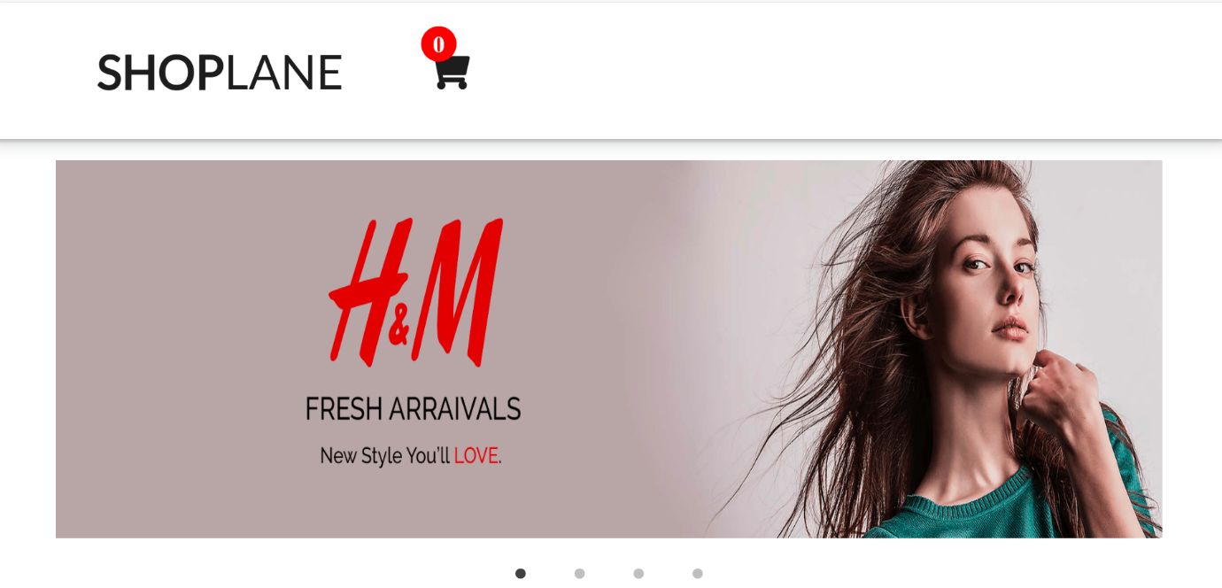

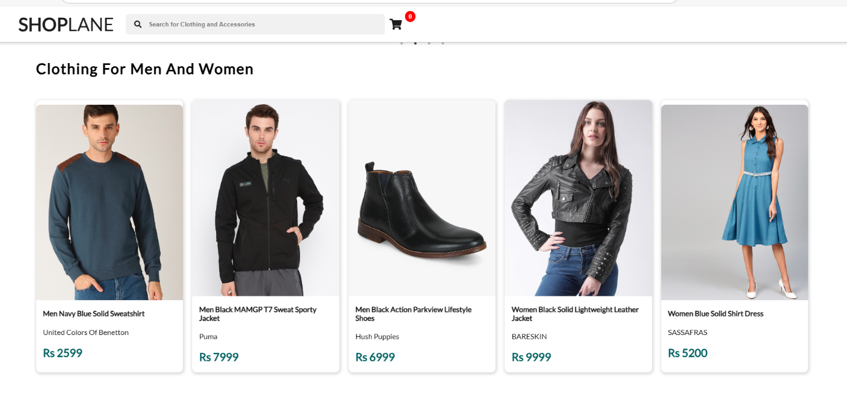

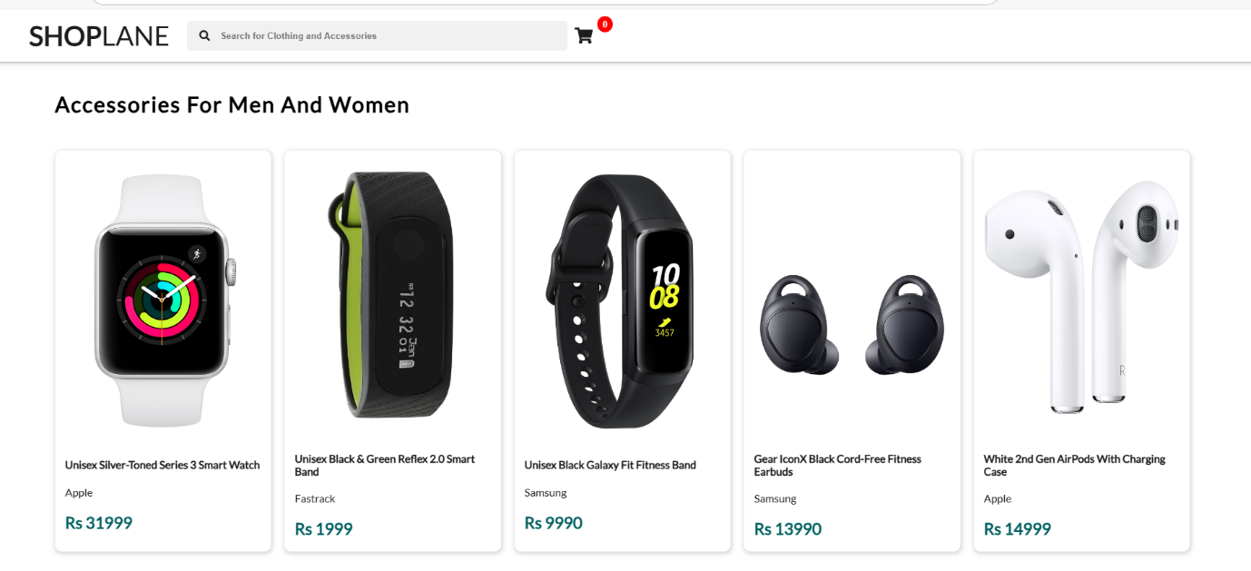

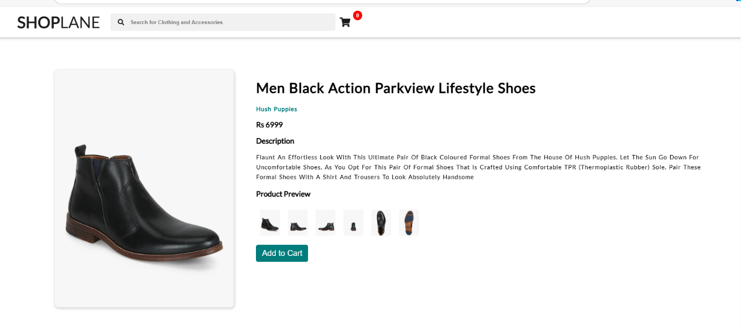

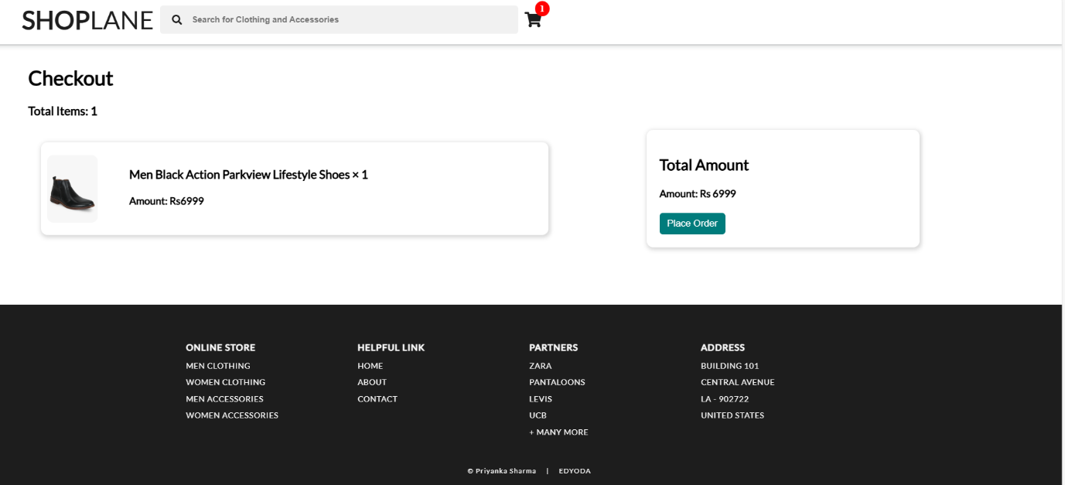

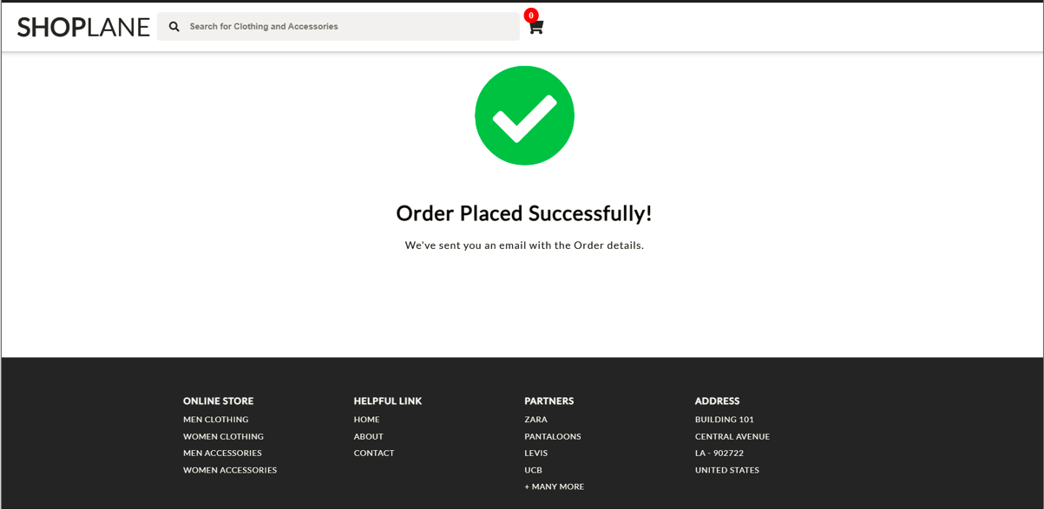

**6 CONCLUSION**

In conclusion, an e-commerce website with the core functionalities of searching, displaying, and placing orders provides a streamlined and user-friendly shopping experience. The search function allows users to easily locate desired products, while the display feature showcases these items with detailed descriptions, images, and prices. The order placement functionality, integrated with secure payment options, ensures a seamless and efficient transaction process. A well-designed search system with filters and sorting options ensures that users can easily narrow down their choices based on preferences like category, price, brand, and more. This functionality is crucial in delivering a user-friendly experience, especially for websites with a large catalog of items. Together, these elements contribute to enhanced customer satisfaction, increased sales, and the overall success of the online business.

**REFERENCES**

* [**https://www.geeksforgeeks.org/**](https://www.geeksforgeeks.org/)
* [**https://www.campcodes.com/**](https://www.campcodes.com/)
* [**https://itsourcecode.com/**](https://itsourcecode.com/)
* [**https://www.studocu.com/**](https://www.studocu.com/)
* [**https://www.slideshare.net/**](https://www.slideshare.net/)